Carla Cesare

Columbus College of Art & Design

**Van de Velde, Henry (1863-1957)**

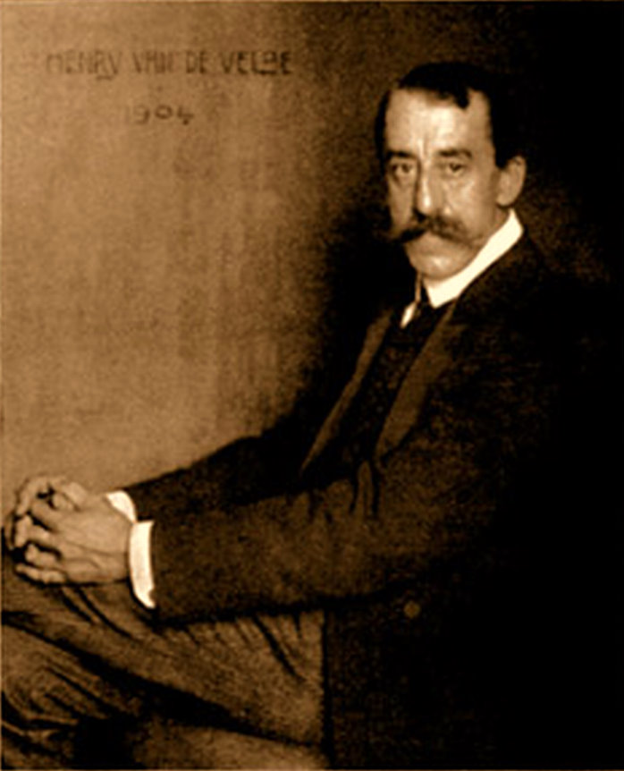

Henry van de Velde

<http://upload.wikimedia.org/wikipedia/commons/9/99/Henry_van_de_Velde_S.jpg>

Architect and designer Henry van de Velde was born in Antwerp, Belgium, the sixth child in a middle-class family. The influence of symbolism from his initial training as a painter, and the movement’s emphasis on the relationship between meaning and form, led to his eventual definition of the importance of the line as a motivating impetus: ‘Line is a force’. This emphasis on line, combined with a growing interest in design reform, led to his career as a preeminent modernist, most prominently through his role as a founder of the Art Nouveau movement, and later work with the Deutscher Werkbund.

Van de Velde began his professional life as a painter. He studied from 1880 until 1883 at the Academie voor Schone Kunsten in Antwerp. His early works reveal the inspiration of Millet, and later Van Gogh and Gauguin; however, regardless of the early influence of Realism and Impressionism, it was the symbolism of neo-impressionist Seurat which had the greatest impact. Through Seurat, van de Velde developed his interest in the line. By 1892, nearly 10 years after he had finished art school, van de Velde discovered the Arts and Crafts movement led by William Morris in England, which led the artist toward his training as an architect and designer.

His first major work as an architect, completed in 1896, was the home he built for his wife and himself, outside of Brussels. This design included not just the building but all the interior, decorative objects as well. His early design elements were heavily influenced by the Arts and Crafts movement. At this time, he also started his own design company, Societe van de Velde. However, it was his meeting and work with Siegried Bing in 1895 that led to his reputation as a pre-eminent art nouveau designer. He designed Bing’s gallery Maison de l’art Nouveau in Paris, where he was able to develop and implement his theory of line, breaking the boundaries of form with ornament. Van de Velde’s work within the Art Nouveau movement solidified his argument that ornament should be a natural outgrowth of form.

An early example of his work includes the lithograph poster for egg white concentrate for the Tropon company (1899). The sinuous lines of the egg white drips from the abstracted egg form into the border which frames the poster, binding the subject matter with the brand name in one continuous line. The Havana Cigar shop in Berlin was also designed in 1899. Here van de Velde, creating all aspects of the interior, draws the form of the wooden cabinets into the linear ornamentation around the interior archways, rising like smoke in the signature art nouveau whiplash line to form an ornamental cornice evoking cigar smoke. His reputation continued to grow, and in 1903 he designed the interior of Nietzche’s archive in Weimar. His deployment of colour and tone through the integrated use of wood, fabric and paint created a restrained yet rhythmic interior, thoroughly modern in its result.

Van de Velde’s work with the Deutsche Werkbund strengthened his stance on the importance of the artistic integrity of the designer over mass production, which came to the forefront in his argument with Herman Muthesius during the planning of the 1914 Werkbund exhibition in Cologne. Van de Velde’s position won. His leadership at the Werkbund gave him the opportunity to recommend Walter Gropius as the first director of the Bauhaus. (As a non-German citizen, van de Velde himself could not lead it.) One of his last positions was in 1925 as Professor of Architecture at the University of Ghent. He continued to work professionally, working on the Rijksmuseum Kroller-Muller in the Netherlands, the Belgian pavilions at the Exposition Universelle in 1937 in Paris, and the World’s Fair in New York in 1939.

Henry van de Velde’s influence as an architect, designer and theorist was influential in the development of modernism as it is known today. His use of line and form, fostered by his interest in maintaining the artist’s influence over the machine without ignoring its potential, left a legacy of modern design well into the 20th century.

**List of Works**

1895–96 Bloemenwer, [Ukkel](http://en.wikipedia.org/wiki/Ukkel), [Belgium](http://en.wikipedia.org/wiki/Belgium)

1895 Interior decoration of [Siegfried Bing](http://en.wikipedia.org/wiki/Siegfried_Bing)'s art Gallery Maison de l'art nouveau in [Paris](http://en.wikipedia.org/wiki/Paris), [France](http://en.wikipedia.org/wiki/France)

1900–02 Interior of the [Folkwang Museum](http://en.wikipedia.org/wiki/Folkwang_Museum) in [Hagen](http://en.wikipedia.org/wiki/Hagen), [Germany](http://en.wikipedia.org/wiki/Germany)

1903 Extension and interior decoration of the [Nietzsche Archive](http://en.wikipedia.org/wiki/Nietzsche_Archive) in [Weimar](http://en.wikipedia.org/wiki/Weimar), [Germany](http://en.wikipedia.org/wiki/Germany)

1907–08 [Hohenhof](http://en.wikipedia.org/wiki/Hohenhof), [Hagen](http://en.wikipedia.org/wiki/Hagen), [Germany](http://en.wikipedia.org/wiki/Germany)

1907–08 Haus Hohe Pappeln, [Weimar](http://en.wikipedia.org/wiki/Weimar), [Germany](http://en.wikipedia.org/wiki/Germany)

1912–13 Palace for Graf Dürckheim in [Weimar](http://en.wikipedia.org/wiki/Weimar), [Germany](http://en.wikipedia.org/wiki/Germany)

1913–14 Werkbund-Theater at the [Deutsche Werkbund](http://en.wikipedia.org/wiki/Deutsche_Werkbund) exhibition in [Cologne](http://en.wikipedia.org/wiki/Cologne), [Germany](http://en.wikipedia.org/wiki/Germany)

1927–28 La Nouvelle Maison, [Tervuren](http://en.wikipedia.org/wiki/Tervuren), [Belgium](http://en.wikipedia.org/wiki/Belgium)

1933–38 Library of [Ghent University](http://en.wikipedia.org/wiki/Ghent_University), [Ghent](http://en.wikipedia.org/wiki/Ghent), [Belgium](http://en.wikipedia.org/wiki/Belgium)

1936–42 Technische School, [Leuven](http://en.wikipedia.org/wiki/Leuven), [Belgium](http://en.wikipedia.org/wiki/Belgium)

1937 Belgian Pavilion at the [1937 Paris Exposition](http://en.wikipedia.org/wiki/1937_Paris_Exposition)

1939 Belgian Building for the 1939 New York World's Fair

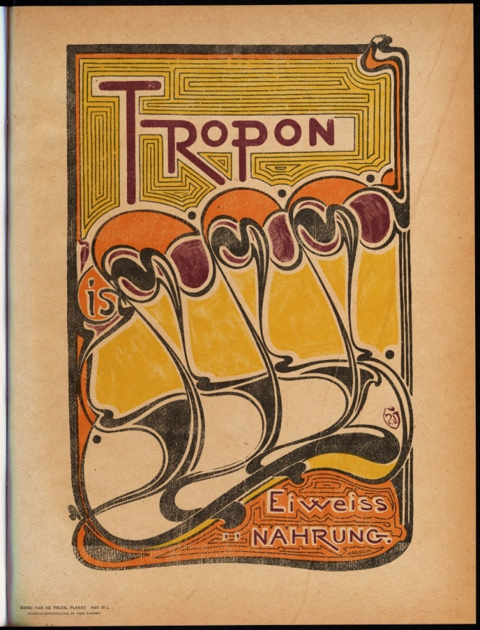

Lithographic poster for the Tropon company (1899)

<http://www.doria.fi/handle/10024/31926>

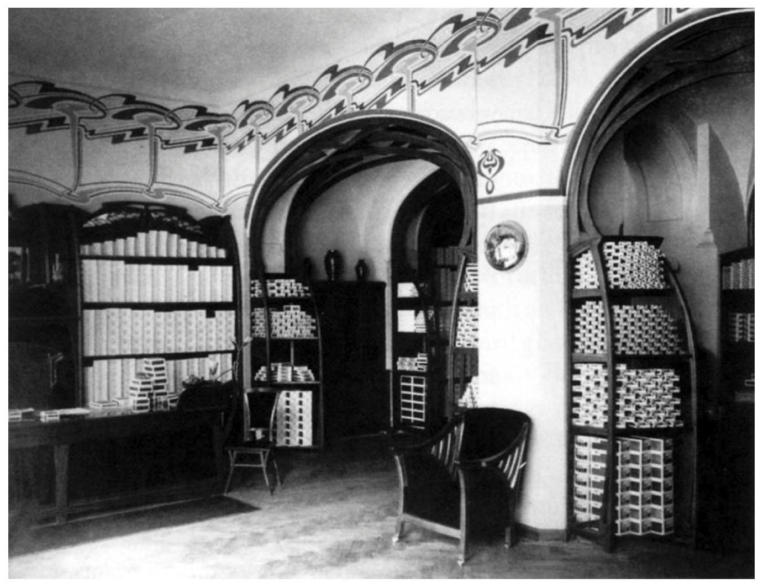

Havana Cigar Shop, Berlin, Germany (1900)

<http://classconnection.s3.amazonaws.com/1553/flashcards/774150/jpg/19.jpg>

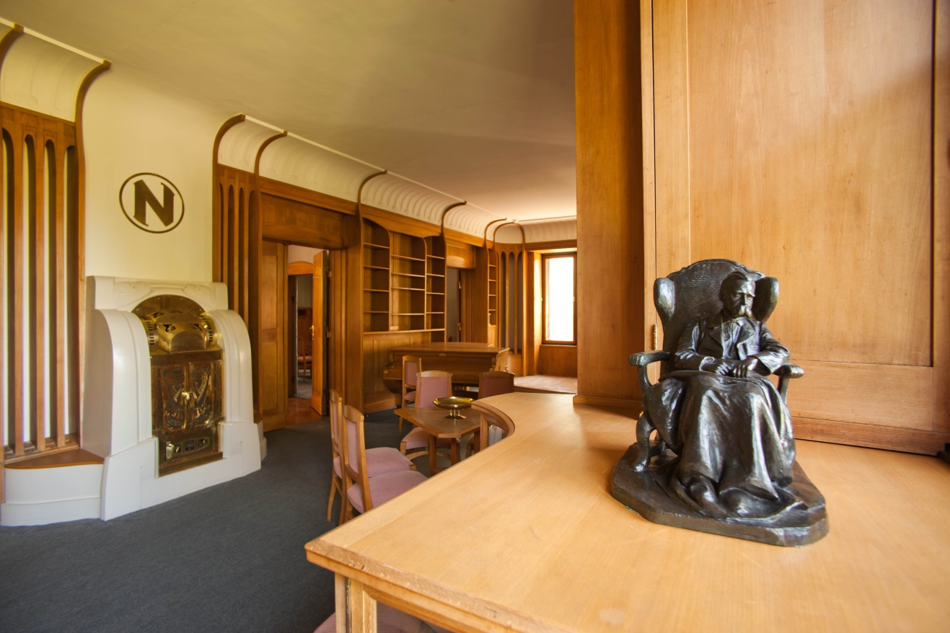

Interior decoration of the [Nietzsche Archive](http://en.wikipedia.org/wiki/Nietzsche_Archive) in [Weimar](http://en.wikipedia.org/wiki/Weimar), [Germany](http://en.wikipedia.org/wiki/Germany) (1903)

<http://www.germany.travel/media/content/press_kit/henry_van_de_velde/bilder_5/Weimar_Nietzsche-Archiv.jpg>